User Table

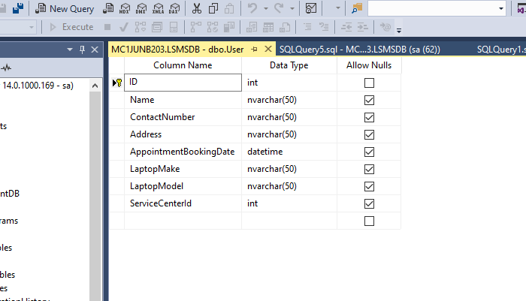

Service center table

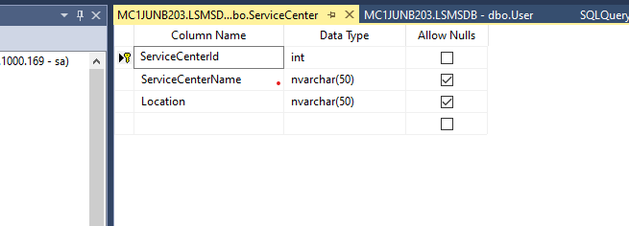

Regestration SP

create procedure spRegister

(

@name nvarchar(50),

@contactNumber nvarchar(50),

@address nvarchar(50),

@bookingDate datetime,

@laptopMake nvarchar(50),

@laptopModel nvarchar(50),

@serviceCenterId int

)

as

begin

insert into [dbo].[User] values(@name,@contactNumber,@address,@bookingDate,@laptopMake,@laptopModel,@serviceCenterId);

end;

Get all service center sp

create proc spGetAllCenters

as

begin

select \* from [dbo].[ServiceCenter];

end;